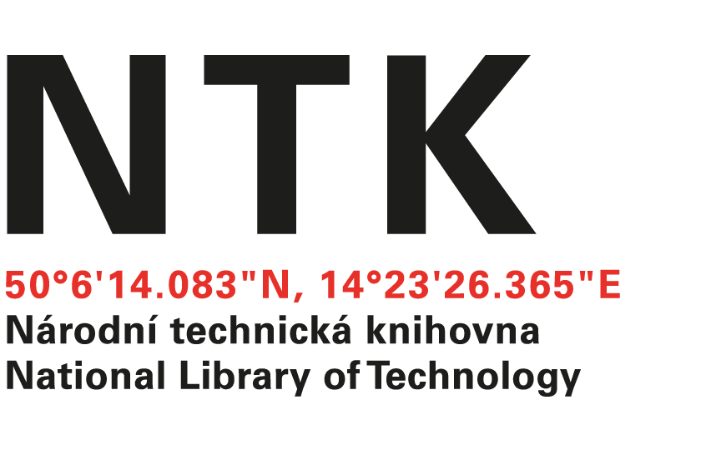
Letter of Gratitude

Prague, 29.11.2017

Letter of Gratitude, Dr. Göran Hamrin (Kungliga tekniska Högskolan, KTH)

To whom it is concerned:

With this letter, I wish to extend my heartfelt gratitude to KTH, the KTH Library, and the Erasmus+ Teaching Mobility program for enabling Dr. Hamrin to visit the National Library of Technology in Prague (NTK) the final week of November, 2017.

Dr. Hamrin’s four lectures enabled over 70 professors, students (of all levels, but primarily doctoral and postdoctoral students), and library faculty with the rare chance to learn firsthand how higher education works at KTH and in Sweden, more broadly. Dr. Hamrin’s lectures sparked many discussions, including the role of the library in the coming years, why (and how) bibliometric research plays a role in the lives of today’s scholars, special hurdles faced by STEM educators in bilingual environments, and new ways academic STEM libraries might contribute to academic and research processes.

This exchange, viewed from a broader perspective, provides an illustration of how important Erasmus+ is to deepening relations between the Central and Eastern European academy and other nations in Europe, providing scholars and students with new perspectives on European ideals, particularly concepts related to transparency, democracy, and ethical norms.

I look forward to any opportunities to host Dr. Hamrin and other KTH colleagues in the future.

With all my best,

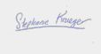

Dr. Stephanie Krueger
Head, Office for Specialized Academic Services
National Library of Technology
stephanie.krueger@techlib.cz
(cell) 775 517 006

