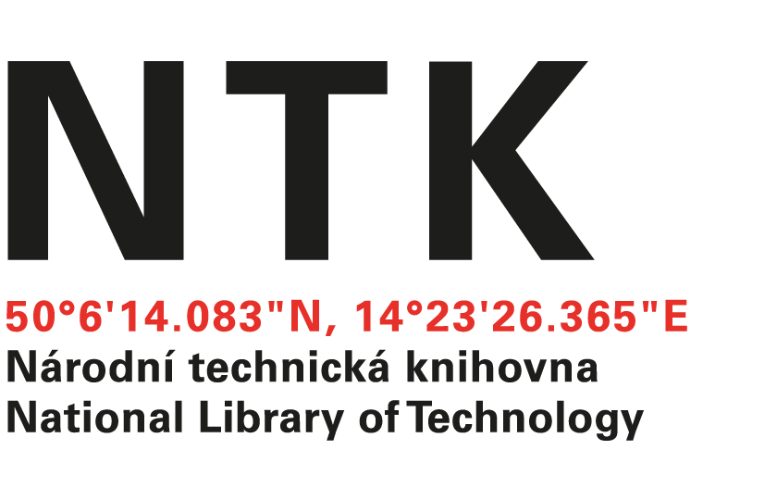
Invitation Letter

ERASMUS+ Teaching Mobility 2017

I hereby formally invite Dr. Göran Hamrin (Kungliga tekniska Högskolan, KTH) to a teaching residence in our library for the period November 20-27, 2017. He will, in addition to conducting seminars at the National Library of Technoloy in Prague (NTK) be conducting workshops for researchers and students from the Czech Technical University (CTU).

Best regards,

Dr. Stephanie Krueger
Head, Office of Specialized Academic Services

Official Stamp: Date: 3.8.2017

