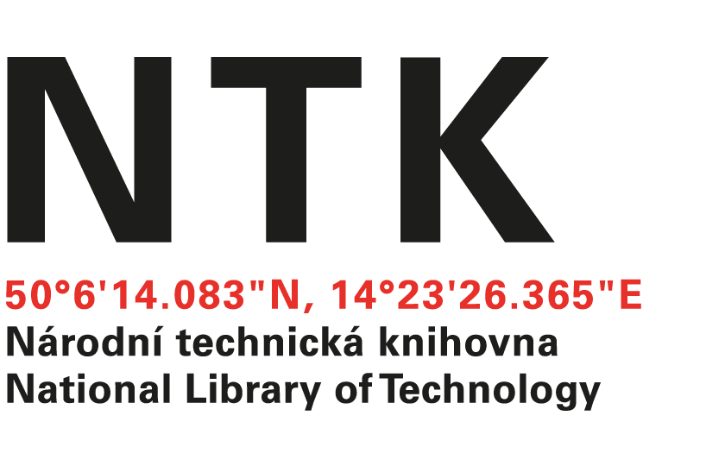
Letter of Acceptance

ERASMUS+
Letter of Acceptance for Erasmus+ Traineeship
2018

I hereby confirm that the following people from Çankırı Karatekin University, Çankırı, Turkey will be our visitors in summer 2018.

First and last names of visitors: Çağlanur merve MAĞAT and Hatice KALKAN

Name of host institution: The National Library of Technology (NTK)
Dates of start and end of mobility period /day/month/year/
from: / 20 / 06 / 2018 /
till: / 15 / 09 / 2018 /.

Responsible person at the host institution
NAME: POSITION: SIGNATURE:
Dr. Stephanie Krueger Head, Office of Specialized Academic Services
STAMP OF THE HOST INSTITUTION:

DATE:

