
The English College, 18.11.2016: Exercises
- ACCESSING RESOURCES FROM HOME (5 minutes+questions)
- Go to: https://www.techlib.cz/en/
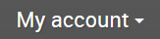
- Select
- Login using library credentials (username and password)
- Explore account options and library website

- SEARCHING ACROSS ALL RESOURCES (10 minutes+questions)
- Go to: https://www.techlib.cz/en/
- In search box, type in a keyword search or phrase of your choice; example:
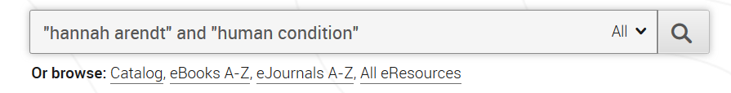
- Take a look at search results. Notice at the left, you can limit your search to full-text, peer-reviewed, content type, date (among other things)
- Select a full-text article or eBook
- View the article in its source database and notice options such as email to yourself, download, view/export citation

- CONTENT GEMS (15 minutes+questions)
- Go to: https://www.techlib.cz/en/2883-eresources
- Scan through the list of databases and find one which interests you; note descriptions are available for each one
- Select a database:
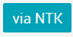
- Explore what is available within the database you selected
- With a partner, talk about what you found and how it might be useful in class or for IB students

NOTES:

